**Prodigy’s Tale**

(Desolated Tree Trunk)



***“The Old- Empire”***

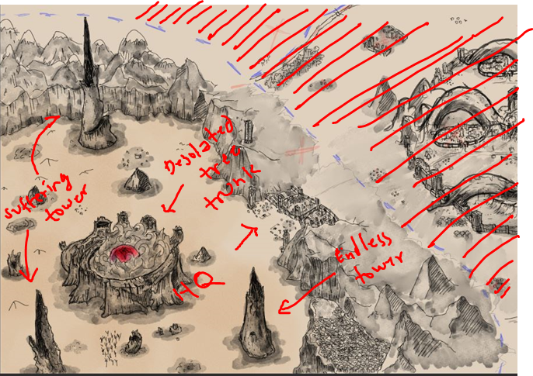

Vast Desert Surrounded by a high mountain range, three peculiar towers, and an old ever-burning gigantic tree trunk.

From the Ancient time the Elven